**Page 1**

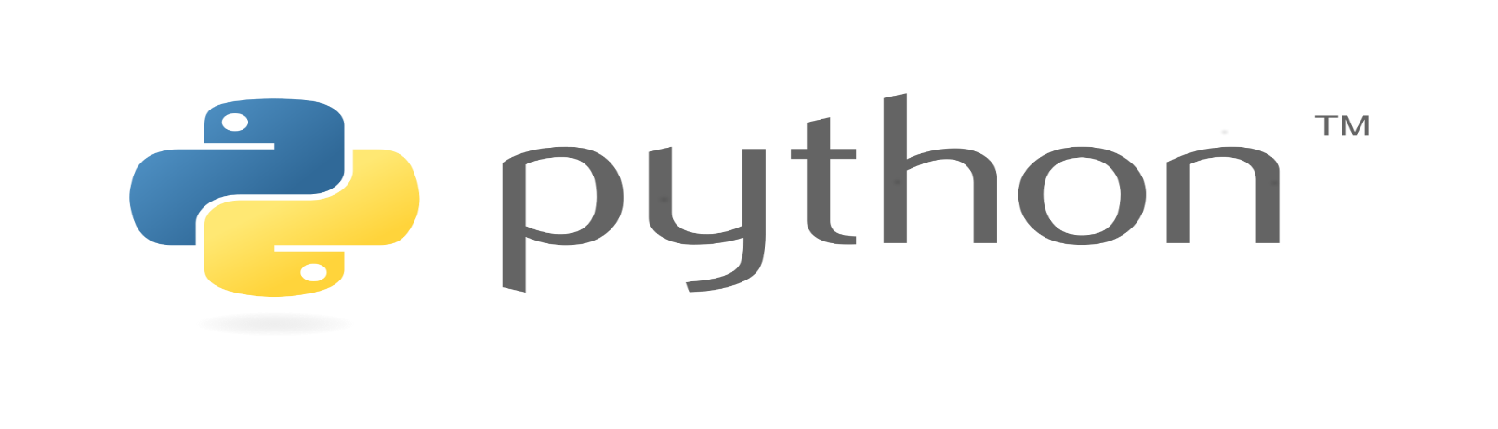Saddleworth School Computing

**What this booklet will cover:**

**1)**Variables and Datatypes

**2)**Useful parts of coding to know

**3)**IF Statements

**4)**For and While Loops

**5)**For Loops

**Why we should learn Python:**

**1)**Easy to use

**2)**Beginner Friendliness

**3)**Very Flexible

**4)**Career Opportunities

Fun fact: Lots of different popular sites were built with Python like;

Google, Dropbox, Pinterest and Instagram.



Created by:

Connor Howarth and Sam Gibson

**Page 2**

**Why we should learn Python**

**Easy to use**

Being a very high level language, Python reads like English, which takes a lot of learning stress away from coding beginners. Python handles a lot of complexity for the people who use it, so it is very beginner-friendly, in that it allows beginners to focus on learning programming concepts and not have to worry about too much details.

**Beginner Friendliness**

Python was designed to be easy to understand and fun to use (its name came from Monty Python so a lot of its beginner tutorials reference it). Fun is a great motivator, and since you'll be able to build prototypes and tools quickly with Python, many find coding in Python a satisfying experience. Python has gained popularity for being a beginner-friendly language, and it has replaced Java as the [most popular introductory language at Top U.S. Universities](http://cacm.acm.org/blogs/blog-cacm/176450-python-is-now-the-most-popular-introductory-teaching-language-at-top-us-universities/fulltext).

**Very Flexible**

Because Python is really flexible, it means there are no hard rules on how to build features, and you'll have more flexibility solving problems using different methods (though the Python philosophy encourages using the obvious way to solve things). Furthermore, Python is also more forgiving of errors, so you'll still be able to compile and run your program until you hit the problematic part.

**Career Opportunities**

From different lists, Python is the second most demanded skill and also the skill with the highest average salary offered (43K – 135K). With the rise of big data, Python developers are in demand as data scientists, especially since Python can be easily integrated into web applications to carry out tasks that require machine learning.

**Page 3**

**Variables and Datatypes introduction**

**Variables** and **Datatypes** are the main part of python, knowing what type of datatype supports the variable you are using will help your understanding of python and coding, there are four different types of datatypes; ***String***, ***Integer***, ***Float*** and ***Boolean***.

**What is a *String?***

A ***string*** is also known as ***str****,* in Python ***strings*** are a sequence of characters like Hello, since Hello is a word this means that any other word is also classed as ***strings****.*

Keep checking what a string is. It may help you memorise what it is.

**For example:**

http://image.prntscr.com/image/d099825a38a84cfc96bb9f1d6508f72e.png

This is a very simple type of code that has been created in Python, this code prints Hello World on the screen, just like this.

This is what the code does when it is being ran.

http://image.prntscr.com/image/d099825a38a84cfc96bb9f1d6508f72e.png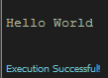

The part of the code which is a **string** is

A more complex version.

This is a ***string*** because it is a word.

**The more complex code is:**

http://image.prntscr.com/image/d099825a38a84cfc96bb9f1d6508f72e.png

http://image.prntscr.com/image/d099825a38a84cfc96bb9f1d6508f72e.pngRemember the reason why this is a ***string*** code is because it is printing a word onto the screen

**Page 4**

**Variables and Datatypes introduction**

This page will be all about ***Integers*** what they are and how they are used in Python coding.

Keep checking what an Integer is. It may help you memorise what it is.

**What is an *Integer?***

***integers*** are also known as***ints***; these are positive or negative whole numbers with no decimal point.

**For example**

http://image.prntscr.com/image/dd4d9bbf22e64a09a69dc31bbbb003ba.png

http://image.prntscr.com/image/dd4d9bbf22e64a09a69dc31bbbb003ba.pngThis is a simple piece of code that is from a more complex code that will be shown below, this code is an ***Integer*** code because it has numbers in the code:

A more complex version.

**The more complex code is:**

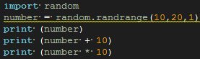

This is what the code does when it is being ran.

When running this code in Python, it will print on the screen like this:

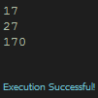

Remember the reason why it is an ***Integer*** code is because it is printing numbers.

**Page 5**

**Variables and Datatypes introduction**

This page will be all about ***Floats***, what they are and how they are used in Python coding.

**What is a *Float*?**

A***Float*** is the opposite of what an ***Integer*** is, a ***Float*** is a decimal number, not a full number like an ***Integer*** is.

**For example:**

Keep checking what a Float is. It may help you memorise what it is.

http://image.prntscr.com/image/7670889fd6d3445f9ebbfd9a50e4899a.png

http://image.prntscr.com/image/7670889fd6d3445f9ebbfd9a50e4899a.pngThis is a simple ***Float*** code; you can tell it is a ***Float*** code because it has the part in the code.

**The more complex code is:**

A more complex version.

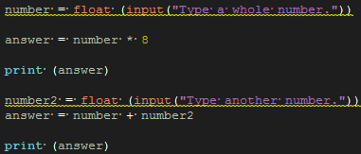

When this code is running in python it will print this

http://image.prntscr.com/image/c5bd0859815d474dabdcd4b177bfc3a0.png

This is what the code does when it is being ran.

After typing in a whole number like 10 and

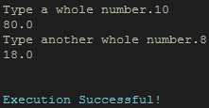another one for example 8 it will print,

Remember the reason why it is a ***Float*** code is because it is printing decimal numbers.

**Page 6**

**Variables and Datatypes introduction**

This page will be all about ***Booleans***, what they are and how they are used in Python coding.

**What is a Boolean?**

A ***Boolean*** is a piece of code that has only two values, Yes or No and Male or Female.

**For Example:**

Keep checking what a Float is. It may help you memorise what it is.

http://image.prntscr.com/image/8ea8a45a37d44f259f50eb4bb86286c4.png

http://image.prntscr.com/image/a80fe49843f447d0ad1251a96f6984dc.pngThis is a very simple piece of ***Boolean*** code; you can tell it is a ***Boolean*** code because it has in it.

**The more complex code is:**

A more complex version.

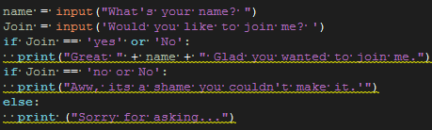

When the code is running in Python it will print this,

http://image.prntscr.com/image/ea2d88c99ab44841a1c2a780d2bda68c.png

After typing your name, it will print this on your screen

http://image.prntscr.com/image/bf35ca86fb33447aad537c48047c9f0e.png

This is what the code does when it is being ran.

When you have typed Yes or No it will print

http://image.prntscr.com/image/70cb637e1acb4dad8416a86a35c9f034.pnghttp://image.prntscr.com/image/69fe3d4d4b184d7b95535715e0f306c7.png

Remember the reason why it is a ***Boolean*** code is because it is printing

**Page 7**

**Useful parts of coding to know**

This page will be all about the useful parts of code to know when wanting to use certain types of codes like printing a blank line or giving a code a waiting time until it prints on the screen or even something simple as what does print do.

**To give a piece of code a waiting time until it prints**

**On the screen:**

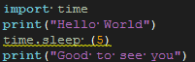

This code will print then 5 seconds later it will print and the part of code that allows this to happen is; http://image.prntscr.com/image/3712e2f1ad5b42afaec526c6715adbc9.png the http://image.prntscr.com/image/3712e2f1ad5b42afaec526c6715adbc9.png can be changed to any number.

**How to print a blank line:**

http://image.prntscr.com/image/c2bf49b25c75433c82ef198e58eda641.png

http://image.prntscr.com/image/c2bf49b25c75433c82ef198e58eda641.pnghttp://image.prntscr.com/image/c2bf49b25c75433c82ef198e58eda641.pngThis piece of code will print ,it will then print a blank line, then will be printed on to the screen.

The piece of code that prints a blank line is; http://image.prntscr.com/image/c2bf49b25c75433c82ef198e58eda641.png

**What does Print actually do?**

If you don’t already know what **Print** does, it actually prints the code you have typed.

**For example:**

http://image.prntscr.com/image/d8f494f723eb429fba69d4e69209cfbe.png

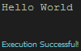This code because it has ***Print*** in front of the code it will print on to the screen like this;

**Page 8**

**Useful parts of coding to know**

This page will be all about the useful parts of code to know when wanting to use certain types of codes or having question about why we use certain things, like what does ***Input*** actually do? Or why do we need to use brackets **()** and speech marks **“”** in the code?

**Why do we need to use brackets () and speech marks “”?**

http://image.prntscr.com/image/29822e6d26154752bdefc17dc0ea212e.pnghttp://image.prntscr.com/image/29822e6d26154752bdefc17dc0ea212e.pngThe reason why we need to use **()** and **“”** whilst coding something like is so the can recognise the code is wanting to print. If you don’t use **()** in this code it will print an error and if you don’t use **“”** in the code an error as well, so using **()** and **“”** will print;

**What does *Input* actually do?**

http://image.prntscr.com/image/45600b97c7d6485a9797e11a4292ffad.png

http://image.prntscr.com/image/45600b97c7d6485a9797e11a4292ffad.pngThe **Input** in this code allows the user or the person who is running the code in Python to type their name and the code that lets the user do this is:

So an **Input** allows the person to type anything when this code is running.

http://image.prntscr.com/image/45600b97c7d6485a9797e11a4292ffad.png**What can be changed:**

Remember whenever something is inside the **brackets** and **speech marks** that is **purple** you are able to change; this is in every code you do.

http://image.prntscr.com/image/6fcfdffeea04445fb641c0d238317857.pnghttp://image.prntscr.com/image/a6c36cf88f6d446cb0cb5bfcb31575c2.png**For example:**

**Page 9**

**Useful parts of coding to know**

This page will be all about the useful parts of code to know when wanting to use certain types of codes and different pieces of code you may not know already like how to make a **quotation** on a piece of code.

**How can you make a *quotation* on a piece of code?**

Making a **quotation** is very easy and is a useful thing to know when it comes to wanting to make a quick **quote** about a piece of code where it won’t be printed out with the rest of code like this;

The code that allows you to make a **quotation** on the code and that won’t be printed with the rest of the code is;

http://image.prntscr.com/image/27661356bfc244109cf52387561e79fa.png

http://image.prntscr.com/image/9a8c53db9e154668b614e0ba9c59ec73.pngThe is the part of the code that makes whatever is typed after it like this http://image.prntscr.com/image/27661356bfc244109cf52387561e79fa.png invisible to Python and will not be printed with the rest of the code.

**A better example:**

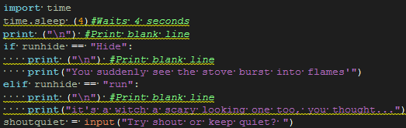

This is a good example because it covers what you have previously read about.

**Page 10**

**If Statements**

What are **If Statements**? What do they do?

An **if statement** is piece of code that allows more than one answer to a question, an **if statement** is built up of **If** and **elif** make sure you don’t use *elseif* because it won’t work just like this;

Keep checking what a Float is. It may help you memorise what it is.

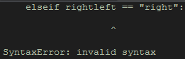

But having **elif** it will work properly.

**For example:**

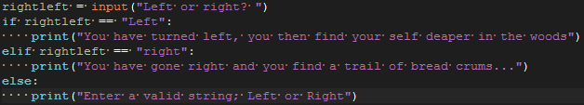

This is a very simple **If Statement**, by looking at the example you can tell it is an **if statement** because it has **if** and **elif** in it. The **else** part of the code prints when the user has entered a different word other than .

**This is what will be printed after the user has entered Left or Right:**

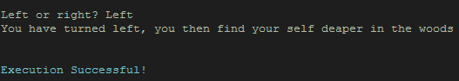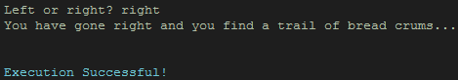

**Page 11**

**While Loops**

This page will be all about **While Loops**, what they are and what we use them for

A **While Loop** is a code that gives the user an infinite number of attempts until a condition is met, this can be useful for passwords.

**For example:**

Keep checking what a Float is. It may help you memorise what it is.

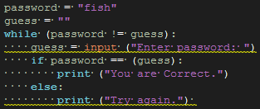

This while loop is a password loop, the password is  and the user has to type fish for the loop to fish. If the user doesn’t input fish it will print;

http://image.prntscr.com/image/e7cde9ee24c54921a5dbc54c5f81677f.png

And if the user inputs **fish** it will print;

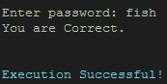

When the condition is met.

The password can be changed to anything and the answer can be changed too, just like this;

Every code can be changed.

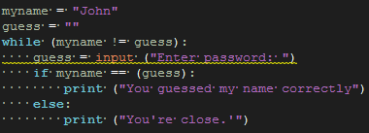

**Page 12**

**For Loops**

This page will be all about **For Loops**, what they do, and how they’re used.

A **For Loop** is a code that allows the user to repeat a segment of code for a set amount of times.

**For Example:**

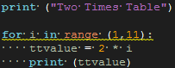

This **For Loop** is a times tables **loop**, the value is 1,11 because there’s 10 numbers between 1 and 11. This will define the as 10 numbers. Creating the ttvalue variable this prints the two times tables, like this;

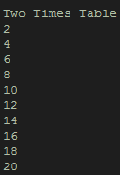

This can be changed in to any other integer to print the users desired times tables.

**What does the * do?**

The in this code;  multiplies the 2 by the variable i, remember that the variable has to be defined;

